Driver Behavior Classification Model
Driver Dashboard

1. Overview
Title: Driver Behaviour Analysis Dashboard
Purpose:
This desktop application provides a visual dashboard to analyze embedded ML model reports, hardware resource usage, and biosignal waveforms. It is designed to help engineers quickly inspect:
- Model metadata (name, target platform, MACC, weights, etc.)
- Flash and RAM usage
- Confusion matrix output from evaluation JSON
- Waveform data (ECG, EEG, EMG, GSR)
- Auto-generated textual analysis
Technology stack:
- Language: Python 3.x
- GUI Framework: PyQt5
- Plotting: matplotlib
- Data handling: json, numpy (indirectly via matplotlib)
- Project structure:
  - main.py – application entry point
  - ui/main_window.py – main dashboard UI
  - parser/report_parser.py – parses text report files
  - widgets/ – reusable UI components (MetricCard, StatusBadge, WaveformCanvas, MemoryCanvas, SectionBox, OverviewTable, etc.)
  - utils/helpers.py – utility functions (e.g. format_int)
  - preprocessed data/ – waveform datasets (*.set files)

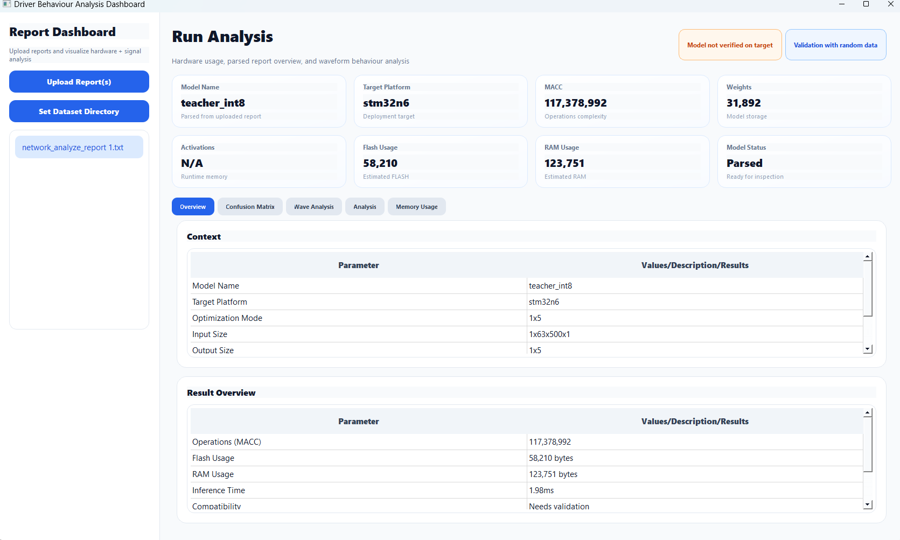

2. User Workflow

2.1 Launching the Application
- Run:
bash
python main.py
- The main window opens with:
  - A sidebar on the left.
  - A main analysis area on the right.
  - No report selected (empty state).

2.2 Loading a Report
- Click “Upload Report(s)” in the left sidebar.
- Select one or more report files (e.g. network_analyze_report_1.txt).
- Each successfully parsed report appears as an item in the report list.
- Select a report from the list:
  - Top metric cards update (model name, target, MACC, weights, flash, RAM).
  - Overview and Result tables populate.
  - Memory Usage tab updates its graph and cards.
  - Analysis tab shows any text analysis from the report.

2.3 Tabs in the Main Area
Tabs under “Run Analysis”:
- Overview
- Confusion Matrix
- Wave Analysis
- Analysis
- Memory Usage

2.3.1 Overview Tab
Shows high-level context and summary:
- Context (OverviewTable):
  - Model Name
  - Target Platform
  - Optimization Mode
  - Input Size
  - Output Size
  - Advanced Settings (placeholder for future options)
- Result Overview (OverviewTable):
  - Operations (MACC)
  - Flash Usage (bytes)
  - RAM Usage (bytes)
  - Inference Time (placeholder value)
  - Compatibility
  - Runtime Info (toolchain/runtime)

2.3.2 Confusion Matrix Tab
Purpose: visualize evaluation results stored in a JSON file.
- Upload JSON button:
  - Opens a file dialog filtered to *.json.
  - Loads a JSON with at least a confusion_matrix key:
json
{
"confusion_matrix": [[50, 2], [3, 45]],
"labels": ["class0", "class1"]
}
- Confusion matrix is displayed in a QTableWidget:
  - Optional row/column labels if "labels" is present and matches the matrix size.
  - Basic validation and error messages for malformed JSON.

2.3.3 Wave Analysis Tab
Purpose: inspect preprocessed biosignal waveforms.
- Controls:
  - Dataset (QComboBox): selects the dataset (ECG_1, EEG_2, EMG_1, GSR_1).
  - Epoch (QSpinBox): selects the epoch index within the dataset.
  - Status label: indicates the current dataset and epoch, or errors.
- Plot:
  - WaveformCanvas (matplotlib) loads .set files from BASE_DATA_DIR.
  - on_dataset_changed:
    - Loads epochs from the selected .set file.
    - Sets spinbox range.
    - Plots epoch 0.
  - on_epoch_changed:
    - Plots the selected epoch on the waveform canvas.

2.3.4 Analysis Tab
- Read-only QTextEdit inside a SectionBox (“Auto Analysis”).
- Shows:
  - Parsed analysis text from the report (if available).
  - Fallback message: “No analysis available.”

2.3.5 Memory Usage Tab
Purpose: visualize Flash and RAM usage in a dedicated view.
Components:
- Graph (MemoryCanvas)
  - Bar chart with two bars: Flash vs RAM (in bytes).
  - Called via:
    - memory_canvas.plot_empty() when no report.
    - memory_canvas.plot_memory(flash_val, ram_val) when a report is selected.
- Flash usage card (SectionBox “Flash Usage”)
  - Main label: flash_label (formatted integer or N/A).
  - Detail line: flash_detail (e.g. “Estimated FLASH: 58,210 bytes”).
- RAM usage card (SectionBox “RAM Usage”)
  - Main label: ram_label.
  - Detail line: ram_detail (e.g. “Estimated RAM: 123,751 bytes”).
Logic:
- reset_memory_tab():
  - Sets labels to N/A.
  - Clears graph to “No data”.
- update_memory_tab_from_report(report):
  - Reads flash_ro and ram_rw from the parsed report.
  - Updates labels using format_int.
  - Calls memory_canvas.plot_memory(flash_val, ram_val).

2.x Dataset Directory Selection

Purpose
The dashboard uses preprocessed biosignal datasets (e.g. ECG, EEG, EMG, GSR) stored as .set files. Originally, these datasets were loaded from a fixed path defined by BASE_DATA_DIR. To make the application more flexible, a “Set Dataset Directory” feature was added so users can change the dataset root directory at runtime without modifying the code.

UI Changes
- A new button is available (e.g. in the Wave Analysis area or sidebar):
  - Button label: Set Dataset Directory
  - Behavior: When clicked, opens a directory selection dialog allowing the user to choose the root folder where datasets are stored.

Behavior
- Initial State
  - The application starts with a default dataset directory:
python
BASE_DATA_DIR = "C:\\...\\preprocessed data"
  - An instance attribute is used to store the current directory:
python
self.base_data_dir = BASE_DATA_DIR
- Selecting a New Directory
  - When the user clicks “Set Dataset Directory”, the slot set_dataset_dir() is invoked.
  - A standard Qt directory dialog is shown:
python
dir_path = QFileDialog.getExistingDirectory(
self,
"Select Dataset Directory",
self.base_data_dir
)
  - If the user selects a directory:
    - self.base_data_dir is updated to the chosen path.
    - A confirmation message is displayed.
    - The dataset combo box is rebuilt to use the new path (via reload_datasets()).
- Updating the Dataset Combo Box
  - The method reload_datasets() rebuilds the items in the dataset selector (QComboBox):
    - Each entry has:
      - A human-readable label (e.g. "ECG_1", "EEG_2").
      - An associated full file path (itemData) pointing to the .set file in the selected directory.
    - Example mapping:
      - "ECG_1" → <base_data_dir>/ECG/ECG_1.set
      - "EEG_2" → <base_data_dir>/EEG/EEG_2.set
      - etc.
  - The waveform status is reset to “no dataset selected” and the plot is cleared.
- Loading Waveforms from the Selected Directory
  - When the user choses a dataset in the combo box, on_dataset_changed() is called.
  - Instead of building the path from a constant, the path stored in itemData is used directly:
python
dataset_path = self.dataset_combo.itemData(index)
  - The waveform loader (WaveformCanvas.load_epochs_from_file) is called with this path.
  - Status text is updated to show the current dataset name (using os.path.basename(dataset_path)) and epoch.
- Status Updates
  - When the directory is changed, but no dataset is selected yet:
    - The status label shows:
Waveform: no dataset selected
  - When a dataset and epoch are successfully loaded:
    - The label shows, for example:
Waveform: dataset=EMG_1.set, epoch=0 (1/234)
  - On errors (e.g. missing .set file), the user sees: Waveform: error loading dataset in the status label, and the plot reverts to a default empty state.

Implementation Summary
- New attributes:
  - self.base_data_dir – current dataset directory (initialized to BASE_DATA_DIR).
- New methods:
  - set_dataset_dir():
    - Opens directory dialog.
    - Updates self.base_data_dir.
    - Calls reload_datasets().
  - reload_datasets():
    - Clears and repopulates the dataset combo with full paths under self.base_data_dir.
- Updated methods:
  - build_wave_tab():
    - Initializes self.dataset_combo and calls reload_datasets() instead of hard-coding relative paths.
  - on_dataset_changed() and on_epoch_changed():
    - Use the full dataset path stored in the combo’s itemData instead of BASE_DATA_DIR.

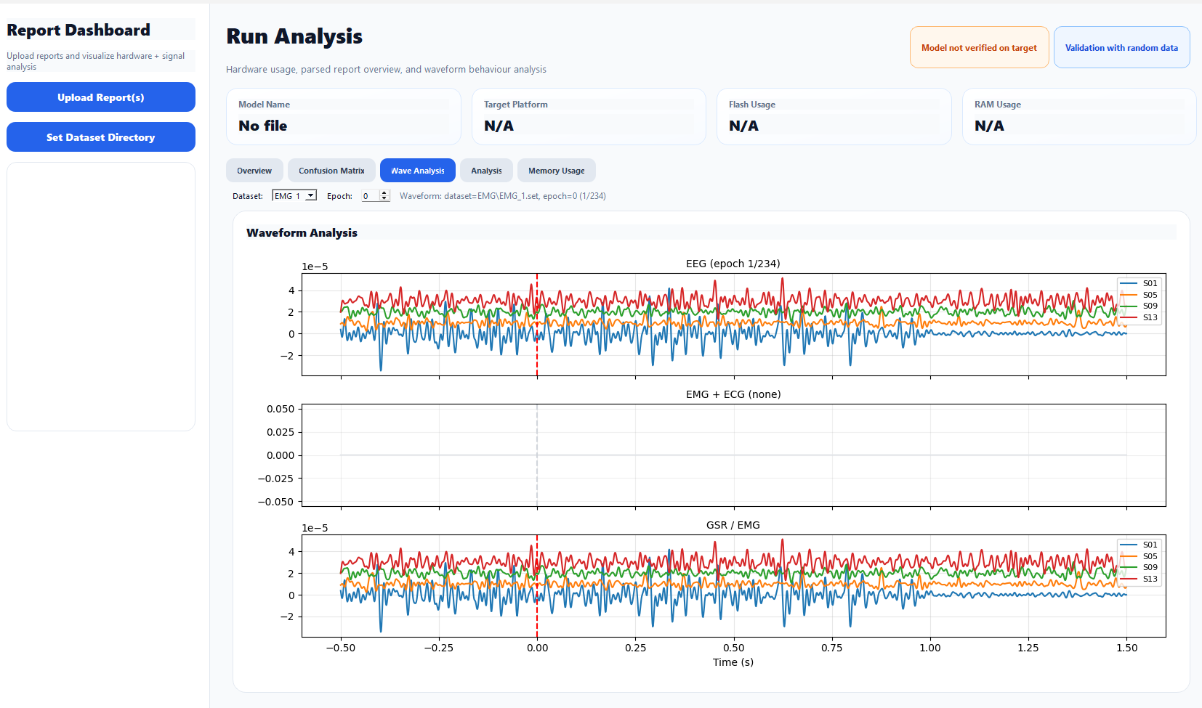

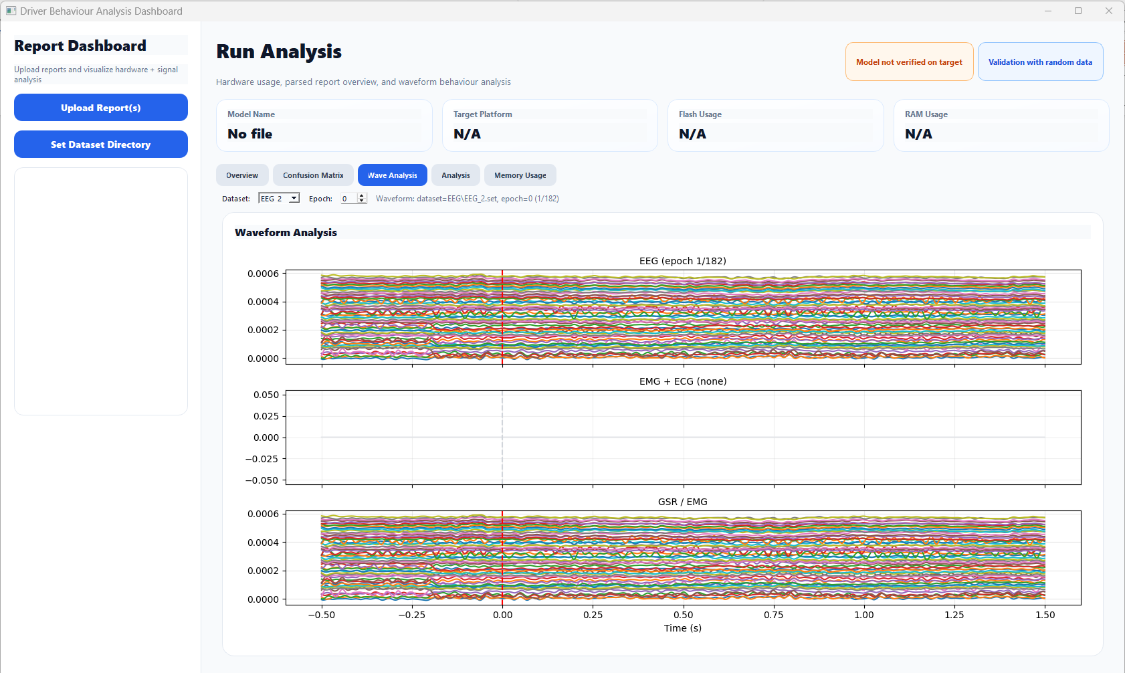
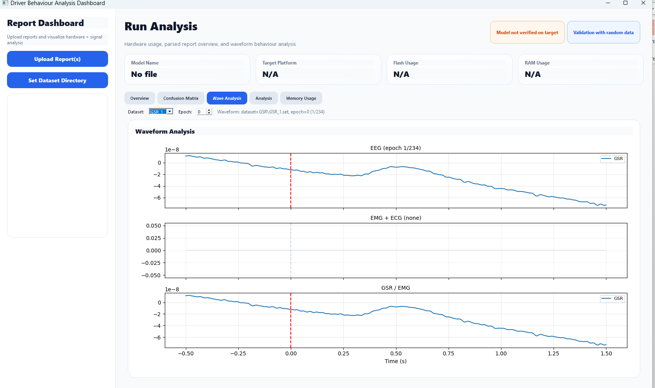

3. Code Architecture

3.1 MainWindow Class (ui/main_window.py)
Responsibilities:
- Create and style the main window.
- Build and wire all UI pieces:
  - Sidebar (report upload & list).
  - Top badges and metric cards.
  - Tabs and their content.
- Manage application state:
  - Loaded reports (self.reports).
  - Currently selected report.
- Coordinate updates across tabs when a report changes.
Key methods:
- __init__: sets up window, style, layout, calls build_sidebar, build_main_area, and set_empty_state.
- Sidebar
  - build_sidebar(root): creates the left panel with:
    - Title/subtitle labels.
    - “Upload Report(s)” button.
    - QListWidget with report names.
- Main Content
  - build_main_area(root): sets QScrollArea, top title row, metric grid, and QTabWidget then calls individual build_*_tab methods.
- Tabs
  - build_overview_tab()
  - build_confusion_tab()
  - build_wave_tab()
  - build_analysis_tab()
  - build_memory_tab()
- Confusion Matrix
  - load_confusion_json(): open file dialog, read JSON, validate, call populate_confusion_table.
  - populate_confusion_table(matrix, labels=None): fill QTableWidget.
- Waveform
  - on_dataset_changed(index), on_epoch_changed(value), build_wave_tab().
- Memory
  - build_memory_tab(): create graph + Flash/RAM cards.
  - reset_memory_tab(): reset labels and graph.
  - update_memory_tab_from_report(report): update labels + graph from a parsed report.
- Metrics & Reports
  - clear_metric_grid(), add_metric(row, col, title, value, subtitle="").
  - set_empty_state(): initial state (no report).
  - load_reports(): open file dialog, parse report files, add to list.
  - display_report(index): main entry point when user selects a report:
    - Update top metric cards.
    - Fill Context & Result tables.
    - Update Memory tab via update_memory_tab_from_report.
    - Reset waveform and analysis text appropriately.

3.2 Supporting Modules
- parser/report_parser.py
  - Reads the plain-text report.
  - Extracts:
    - model_name
    - target
    - macc
    - weights
    - activations
    - flash_ro
    - ram_rw
    - Optional analysis text.
  - Returns a dict used by display_report.
- widgets/metric_card.py
  - Custom card with title, value, subtitle, used in the metric grid.
- widgets/badge.py
  - StatusBadge for status indicators (“Model not verified on target”, etc.).
- widgets/section_box.py
  - Container with a title and rounded background.
- widgets/overview_table.py
  - Simple key/value table for Context and Result sections.
- widgets/waveform_plot.py
  - WaveformCanvas: matplotlib figure for plotting waveforms.
- widgets/memory_plot.py
  - MemoryCanvas: matplotlib figure for plotting Flash vs RAM as a bar chart.
- utils/helpers.py
  - format_int(value): formats integers with thousand separators, safe for None.

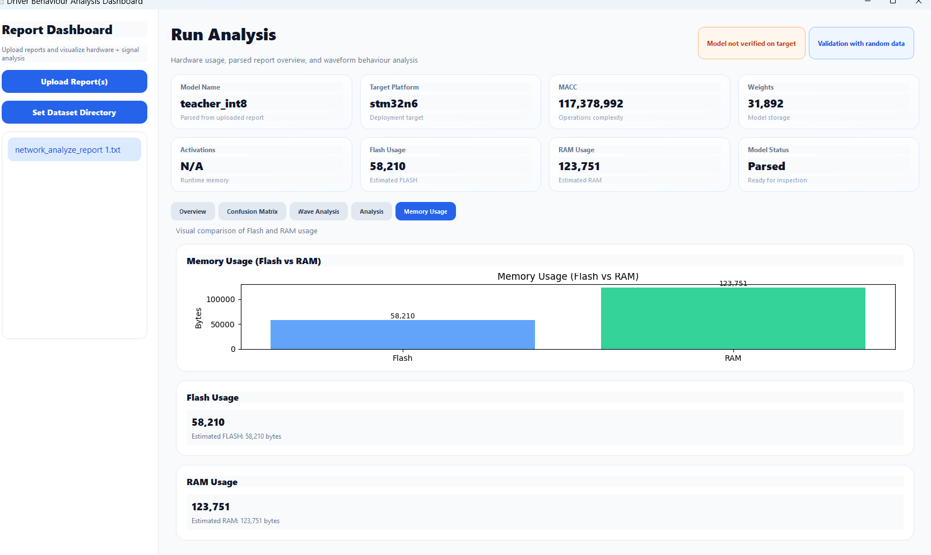4. Data Formats

4.1 Report Files
- Input: .txt report produced by some network analysis tool.
- Parsed fields (example):
  - model_name: "teacher_int8"
  - target: "stm32n6"
  - macc: 117378992
  - weights: 31892
  - activations: …
  - flash_ro: 58210
  - ram_rw: 123751
  - analysis: free-form text
All fields are stored in a dict and kept in self.reports list.

4.2 Confusion Matrix JSON
- exported after model training and can be visuzalized in GUI
- Required key: "confusion_matrix" – 2D list of numbers.
- Optional key: "labels" – list of labels used for both rows and columns.
Example:
json
{
"confusion_matrix": [
[50, 2, 3],
[4, 45, 1],
[0, 3, 60]
],
"labels": ["class0", "class1", "class2"]
}

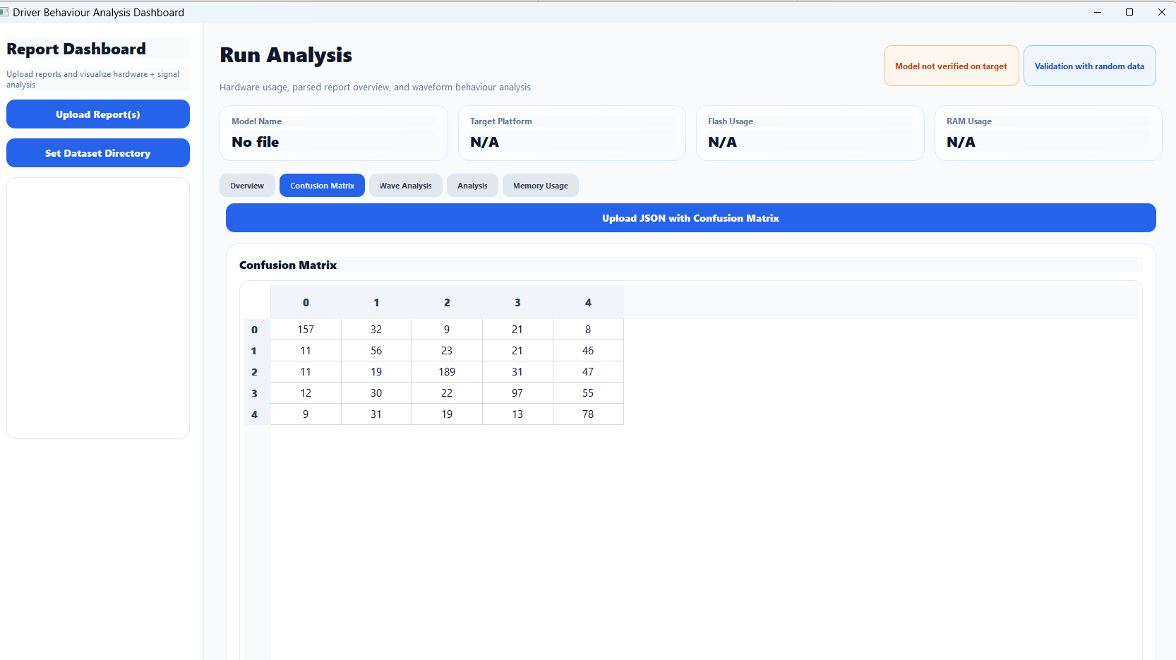

5. Installation & Requirements

5.1 Python Requirements
requirements.txt (example):
text
PyQt5
matplotlib
numpy
scipy
pandas
mne
Install:
bash
pip install -r requirements.txt

5.2 Running
bash
python main.py

